CASPIA Game

https://github.com/BarishYumerov/Team---Caspia-
 | Working on | Done
Barush Yumerov | Lives Function | Barrel and Barrel movement & Lives Function
Nelly Mincheva |  | Character & images  Blur effect  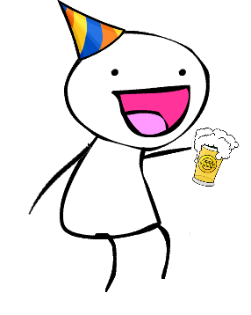  Background style
Martin Draganov
Yanko Aleksandrov |  | Sound, Start Screen .psd and animation, main.js fixes and improvements
Svetoslav Ivanov | Collision detections | Barrel movement & Score
Ana Kaneva | Score Function; Jump | Jump, picture corrections  & Score

You are free to decide what to do so go on :D
*Grey are optional… if we have enough time

Things to do:
how to play
End of the game (Play again and score)
Change the speed of coming barrels
Sounds and volume control button
Loading bar

← Pesho A.K.A. “Pitch”
Полезно:
https://www.youtube.com/watch?v=hUCT4b4wa-8 animation on canvas
http://www.developphp.com/view.php?tid=1228 ← loading bar
https://www.youtube.com/watch?v=CSzgYqtPoXo ← softuni workshop
http://www.williammalone.com/articles/create-html5-canvas-javascript-game-character/2/
http://fc02.deviantart.net/fs70/f/2012/178/3/a/flash__jumping_man____by_sariasong64-d554g2h.gif
http://www.somethinghitme.com/2013/01/09/creating-a-canvas-platformer-tutorial-part-one/
← character example

************************************************

if(beers>3) isPeshoDrunk = true; // Help Pesho to not get drunk!
if(isPeshoDrunk) examPoints = 0;

Pesho has an exam tommorow.
If he drinks too much beers, he’ll fail. Help him not to get drunk by avoiding beer barrels.
Press space bar to make him jump.
After the third beer, he’ll get drunk, so please be careful.

